Joel Cooper
SDEV153-B2B
4/1/2026

Please see the link for github

index.html updates – Verification Screenshot
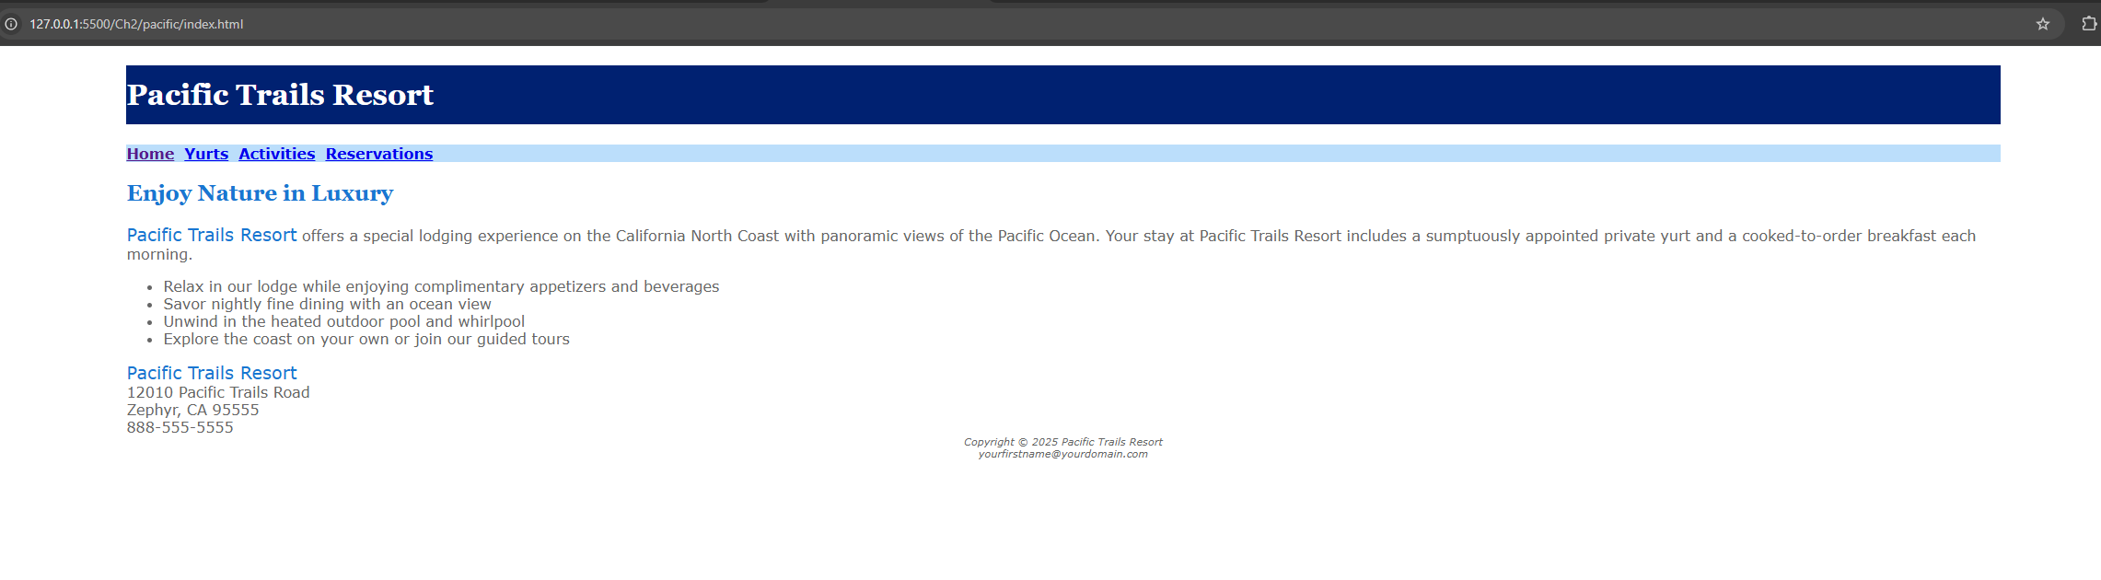
yurts.html updates – Verification Screenshot
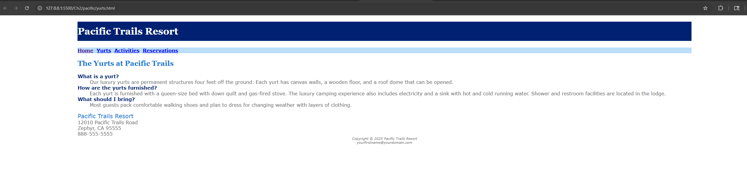
W3C HTML Validation – No Errors (index.html)
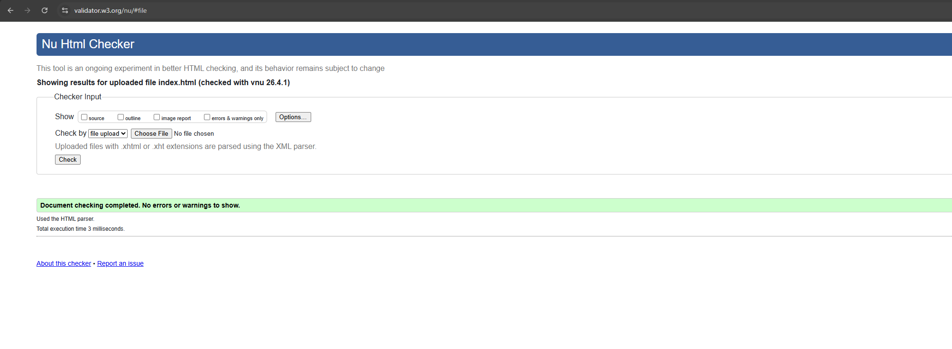
W3C HTML Validation – No Errors (yurts.html)
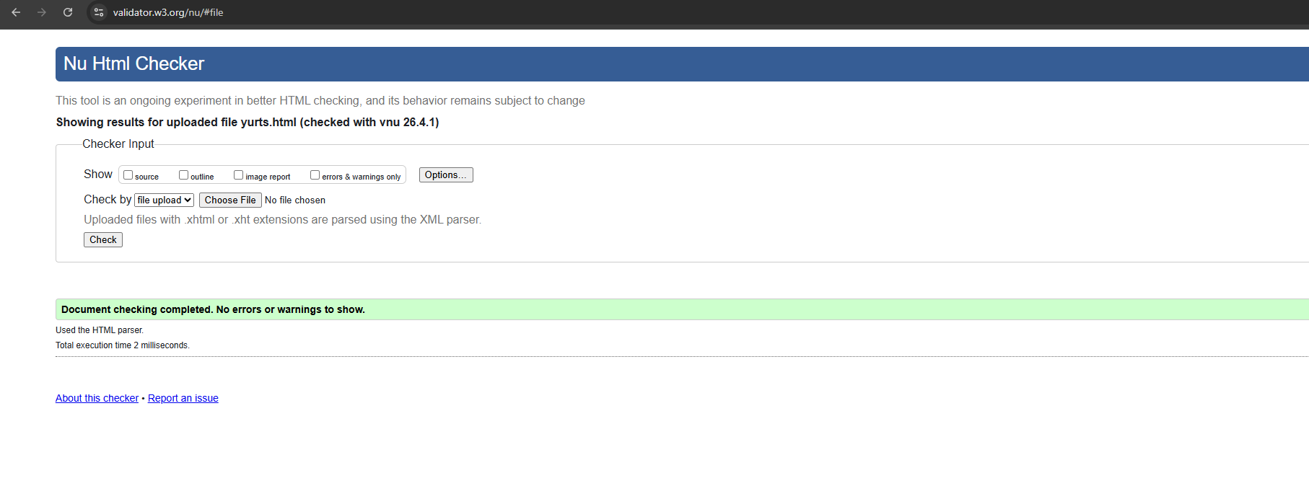
W3C CSS Validation – No Errors
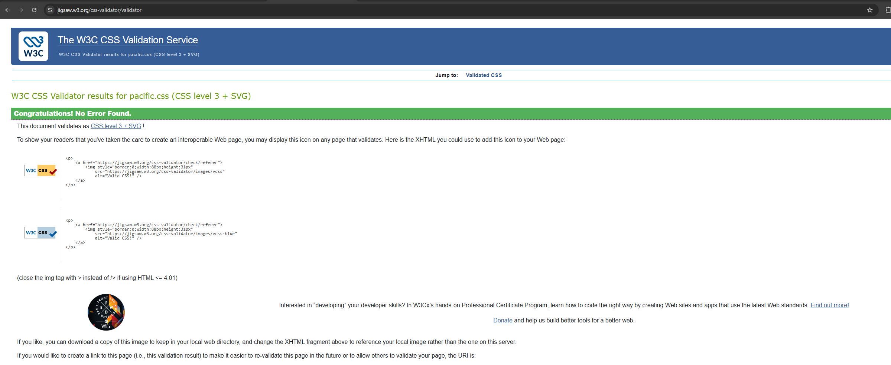

ind

